Jose Rodriguez
06/07/2026
CSD325 Module 1.3 Assignment
On the Wall + Flowchart(s)

Flowchart
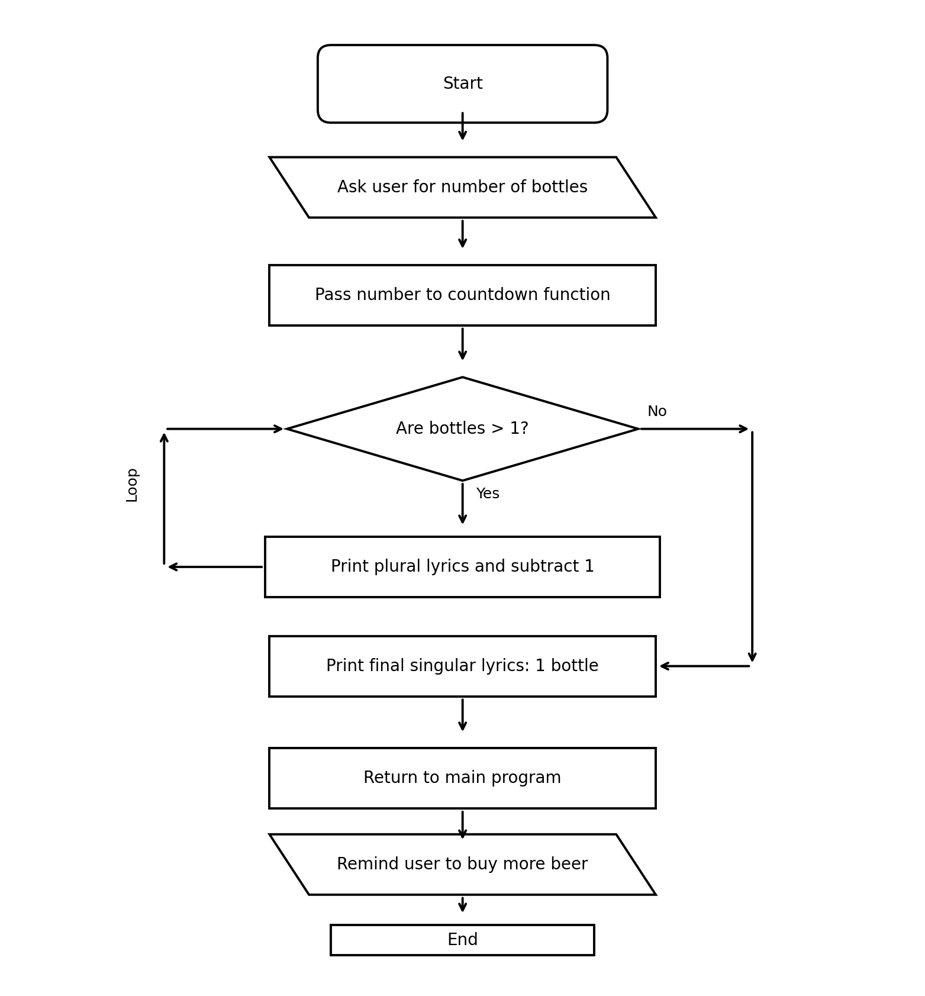

Python Code
# Jose Rodriguez
# CSD325 Module 1.3 Assignment
# On the Wall + Flowchart(s)
# This program asks the user for a number and counts down the bottles of beer.

def countdown(bottles):
# This function controls the countdown lyrics.
while bottles > 1:
print(str(bottles) + " bottles of beer on the wall, " + str(bottles) + " bottles of beer.")
bottles = bottles - 1

if bottles == 1:
print("Take one down, pass it around, 1 bottle of beer on the wall.\n")
else:
print("Take one down, pass it around, " + str(bottles) + " bottles of beer on the wall.\n")

print("1 bottle of beer on the wall, 1 bottle of beer.")
print("Take one down, pass it around, 0 bottles of beer on the wall.\n")

def main():
print("On the Wall Program")
print("-------------------")

bottles = int(input("How many bottles of beer are on the wall? "))

countdown(bottles)

print("Time to buy more beer!")

main()

